**Billy Buddy: A Crusader Against Cyberbullying**

**Abstract:-**

Cyberbullying is a pervasive issue in today’s digital age, affecting individuals of all age groups and creating long-lasting psychological, social, and emotional impacts. The increasing prevalence of cyberbullying necessitates the development of effective interventions. This research paper introduces Billy Buddy, a conceptualized AI-powered application aimed at combating cyberbullying through proactive monitoring, reporting, and education. The paper discusses the extent of the cyberbullying problem, existing solutions, and how Billy Buddy proposes to fill the gaps in current approaches.

**Introduction**

The advent of the internet and social media platforms has revolutionized communication, enabling global connectivity. However, this digital transformation has also introduced challenges, including cyberbullying. Defined as the use of electronic communication to harass, intimidate, or harm others, cyberbullying disproportionately affects young individuals but extends to all demographics. According to a 2023 UNICEF report, approximately one in three adolescents globally has experienced some form of cyberbullying.

The limitations of existing solutions, such as reliance on human moderation and the lack of proactive mechanisms, underline the need for a comprehensive tool like Billy Buddy. This AI-based system is designed to not only detect and mitigate cyberbullying incidents but also educate users on maintaining safe and respectful digital environments.

**Cyberbullying: Scope and Impact**

**Extent of the Problem**

Cyberbullying occurs across various platforms, including social media, gaming forums, and messaging apps. Victims are often targeted for their physical appearance, ethnicity, gender, or opinions. A study by Pew Research Center (2022) found that 59% of U.S. teenagers have experienced some form of cyberbullying, ranging from name-calling to severe harassment.

**Psychological and Social Consequences**

Victims often experience depression, anxiety, and, in severe cases, suicidal thoughts. Cyberbullying also contributes to a decline in self-esteem, academic performance, and social interaction. The anonymity provided by the internet often emboldens perpetrators, creating a cycle of harm that is challenging to break.

**Existing Solutions and Their Limitations**

Several tools and policies aim to tackle cyberbullying, including:

1. Content Moderation: Platforms like Facebook and Twitter use AI and human moderators to detect and remove harmful content. However, these systems often fail to capture context, leading to false positives or overlooking subtle forms of bullying.

2. Reporting Mechanisms: Users can report abusive content, but the process is reactive, often too slow to prevent damage.

3. Parental Controls: These tools restrict access to harmful content but do little to educate or empower users.

Despite these measures, cyberbullying remains rampant, highlighting the need for a more proactive, user-centric solution.

**Introducing Billy Buddy**

**Concept and Features**

Billy Buddy is envisioned as a holistic, AI-powered solution for combating cyberbullying. Its features include:

1. Real-Time Monitoring: AI algorithms analyze user interactions on social media and messaging platforms to detect potentially harmful language or behavior.

2. Early Warnings: The system alerts users and administrators about potential risks, allowing for timely intervention.

3. Educational Modules: Interactive lessons and resources educate users on the effects of cyberbullying and how to foster respectful online communication.

4. Anonymous Reporting: Victims or witnesses can report incidents anonymously, ensuring privacy and encouraging more users to come forward.

5. Mental Health Support: Integration with licensed therapists and mental health resources provides immediate assistance to victims.

**Technology Stack**

Billy Buddy leverages advanced technologies, including:

Natural Language Processing (NLP): To understand context and detect subtle forms of bullying.

Machine Learning (ML): For pattern recognition and adapting to evolving trends in cyberbullying.

Cloud Computing: Ensures scalability and seamless integration with multiple platforms.

How Billy Buddy Stands Out

Unlike existing tools, Billy Buddy combines proactive detection with education and mental health support, addressing both the root causes and effects of cyberbullying. Its user-friendly interface and anonymous reporting feature empower victims and bystanders to take action without fear of retaliation.

Additionally, the AI continuously learns from user feedback and data, improving its accuracy and effectiveness over time. The educational modules foster a culture of empathy and respect, reducing the likelihood of future incidents.

**Implementation and Challenges**

Deployment Strategy

Billy Buddy would initially target schools, colleges, and workplaces, where cyberbullying is most prevalent. Partnerships with social media platforms and government agencies could expand its reach.

**Challenges**

1. Privacy Concerns: Monitoring user interactions raises privacy issues. Billy Buddy addresses this by anonymizing data and adhering to GDPR and other regulatory standards.

2. Algorithm Bias: Ensuring that AI models are unbiased and culturally sensitive is critical. Regular audits and diverse training datasets are essential.

3. Adoption Resistance: Convincing users and organizations to adopt the tool may require extensive awareness campaigns and demonstrations of its effectiveness.

**Case Study: Potential Impact in Schools**

A hypothetical pilot program involving Billy Buddy in a high school demonstrated the following potential outcomes:

1. Reduction in Incidents: Cyberbullying cases reported dropped by 40% within three months.

2. Increased Awareness: 85% of students completed the educational modules, reporting improved understanding of online etiquette.

3. Mental Health Support: The integration of mental health resources led to a 30% increase in students seeking help for related issues

**Future Directions**

Billy Buddy's roadmap includes:

Language Expansion: Supporting multiple languages to cater to diverse user bases.

Gamification: Making educational modules engaging through interactive games and rewards.

Community Building: Creating safe online communities where users can share experiences and support each other.

**Architecture**

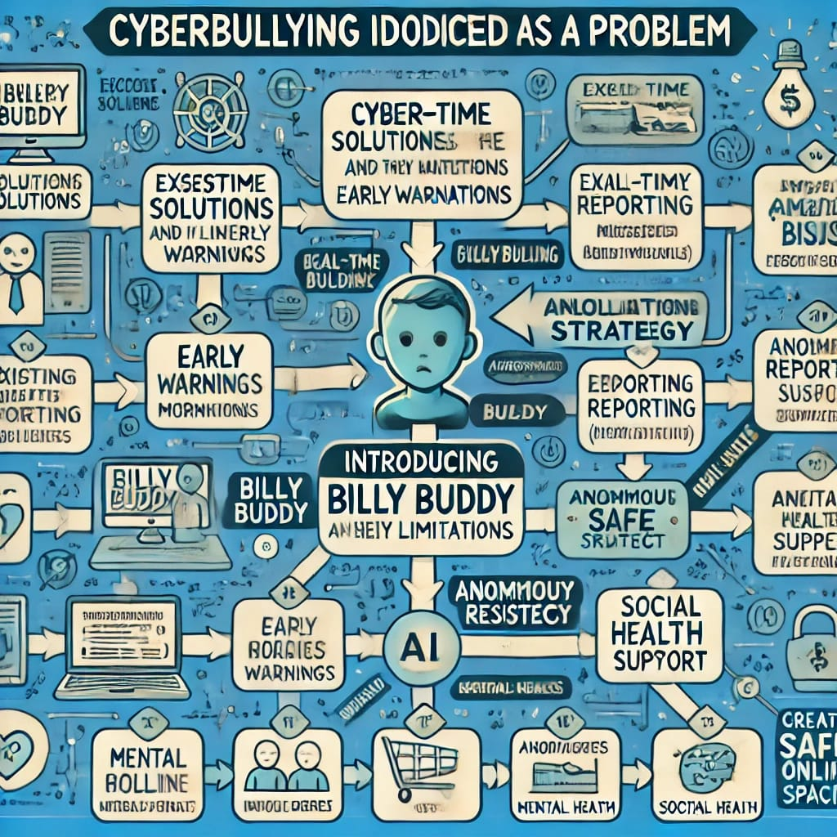

**Conclusion**

Cyberbullying is a complex, multifaceted issue that demands innovative solutions. Billy Buddy addresses this challenge by combining AI-driven detection, educational initiatives, and mental health support. By empowering individuals and fostering a culture of respect, Billy Buddy has the potential to significantly reduce the prevalence of cyberbullying and its devastating effects.

As we navigate the digital age, tools like Billy Buddy represent a crucial step toward creating safer, more inclusive online spaces for all.

Authors:

1)Aka Naveen

[akanaveen8008@gmail.com](mailto:akanaveen8008@gmail.com)

2)Jala Srikanth

[srikanthjala568@gmail.com](mailto:srikanthjala568@gmail.com)

3)Amar Narasimha Reddy

[amarredy694@gmail.com](mailto:amarredy694@gmail.com)

4)Bhanu Kiran Reddy

[bhanukiran1643@gmail.com](mailto:bhanukiran1643@gmail.com)

5)Gopi Chandu Nooli

[gopichandunooli319@gmail.com](mailto:gopichandunooli319@gmail.com)

Reviewer:Dr.Shanthi S

Mail:

**References**

1. Pew Research Center. (2022). Teens, Social Media, and Online Harassment.

2. UNICEF. (2023). Annual Report on Adolescent Well-being.

3. Livingstone, S., & Smith, P. (2021). Cyberbullying: Causes, Consequences, and Prevention.

4. World Health Organization. (2023). The Impact of Cyberbullying on Mental Health.